Filter Assembly Instructions:

Special Note: All Instructions are also available on video at: www.exfog.com
DISCLAIMER:
- DO NOT attach manifolds without viewing/reading the manifold attachment instructions. Manifolds attach only ONE WAY and if improperly applied, you can damage the track, or the unit.
- Product is for recreational use only.

Directions For Use:

Important Note: When placing the Manifolds and the filtration cartridge on the track, they must be installed with the small “barb” facing away from the track. Attempting to install the manifold in the opposite direction can damage the track. If you are not 100% certain how to install after reviewing these instructions, please see our video at: www.exfog.com

Forcing nub into the track will cause damage, so ensure they are facing outward and are the last

- Install the Filter Cartridge onto the unit nubs last. Forcing nubs into track will cause damage)
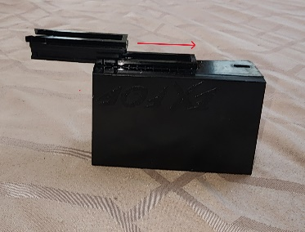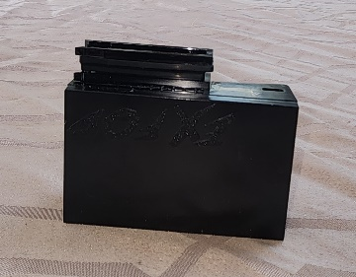

Correct filter assembly – Proper Filter Attachment Complete
Nub is away from the unit

- Install Manifold onto the filter:
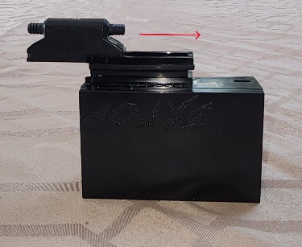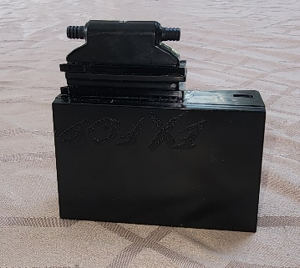

Repeat above process with manifold
Ensuring nubs are facing away Proper Manifold Attachment Complete

  - Attach the filters as follows:
Ensure the small “nub” or “bump” at the end of the filter cartridge is positioned on the far side of the track (the manifold should slide about ¾ of the way into the track before the nub enters the track.
    - Slide the filter slowly into the track, until you see the nub enter and move into the small “notch”, making a clicking noise, which indicates it is secure.
    - Remove the filter cartridge by just adding pressure in the opposite direction until the manifold slides off.
    - If this is done properly, the filter will slide very smoothly into position until it “clicks” into place. If it does not easily slide on or off.
  - Attach the manifold as follows:
Ensure the small “nub” or “bump” at the end of the manifold is positioned on the far side of the filter track (the manifold should slide about ¾ of the way into the track before the nub enters the track.
    - Slide the manifold slowly into the filter track, until you see the nub enter and move into the small “notch”, making a clicking noise, which indicates it is secure.
    - Remove the manifold by just adding pressure in the opposite direction until the manifold slides off.
    - If this is done properly, the filter will slide very smoothly into position until it “clicks” into place. If it does not easily slide on or off.

WARNINGS / NOTIFICATIONS:
The filter cartridge supplied for the ExFog AntiFog Unit are specifically designed for this device and should not be used for any other purpose than it’s intended use
The filter cartridge uses MERV13 rated filtration material which is suitable for filtering out particles as low as.3 microns. The filtration is designed to filter most particles, such as dust, dander, pollen, and bacteria. This filter DOES NOT filter viruses such as, but not limited to COVID-19. It will not offer protection against these viruses and should not be used for this purpose.
As with any filtration system, they are not 100 percent effective, and all appropriate measures should be taken to ensure proper protection.

